|  |  |  |  |  |  |  |  |  |  |  |  |  |  |  |  |  |  |  |  |
| --- | --- | --- | --- | --- | --- | --- | --- | --- | --- | --- | --- | --- | --- | --- | --- | --- | --- | --- | --- |
| **INTERSTATE CONTAINER CORPORATION** | | | ***Date:* 08/23/2016** | ***Spec #:*** | | | | | | | | | | ***Design #:*** | | **160523-02** |  |  |  |
|  |  |
| ***Customer:* DeMet's Candy** |  |  |  |  |  |  |  |  |  |  |  |  |  |  |  |  |  |  |  |
|  |  |  |  |  |  |  |  |  |  |  |  |  |  | ***Cut*** | **151 in.** | |  |  |
|  |  |  |  |  |  |  |  |  |  |  |  |  |  |  |  |
| ***Description:* Shipper- Walgreens 6/7oz box tray [Left handed 1/4"gap]** | | | |  |  |  |  |  |  |  |  |  |  |  |  |  |
|  |  |  |  |  |  |  |  |  |  |  | ***Crease*** | **102 in.** | |  |  |
|  |  |  |  |  |  |  |  |  |  |  |  |  |
| ***Style:* RSC** | ***Revision Info:* [0] 04/29/2016:** | |  |  |  |  |  |  |  |  |  |  |  |  |  |  |
|  |  |  |  |  |  |  |  |  |  |  |  |  |  |  |  |  |
|  |  |  |  |  |  |  |  |  |  |  |  |  |  |  |  |  |
| ***I.D. :* 10+1/4 x 7+5/8 x 7+1/2** | ***Blank size:*** | **15+5/16 x 37+3/4** |  |  |  |  |  |  |  |  |  |  |  |  |  |  |  |  |  |
|  |  |  |  |  |  |  |  |  |  |  |  |  |  |  |  |  |
| ***Board:* 44 B K** | ***Combination:*** | **42-36M-42** | ***Designer:* Alan Groff** |  |  |  |  |  |  |  |  |  |  |  |  |  |  |  |  |
|  |  |  |  |  |  |  |  |  |  |  |  |  |  |  |  |

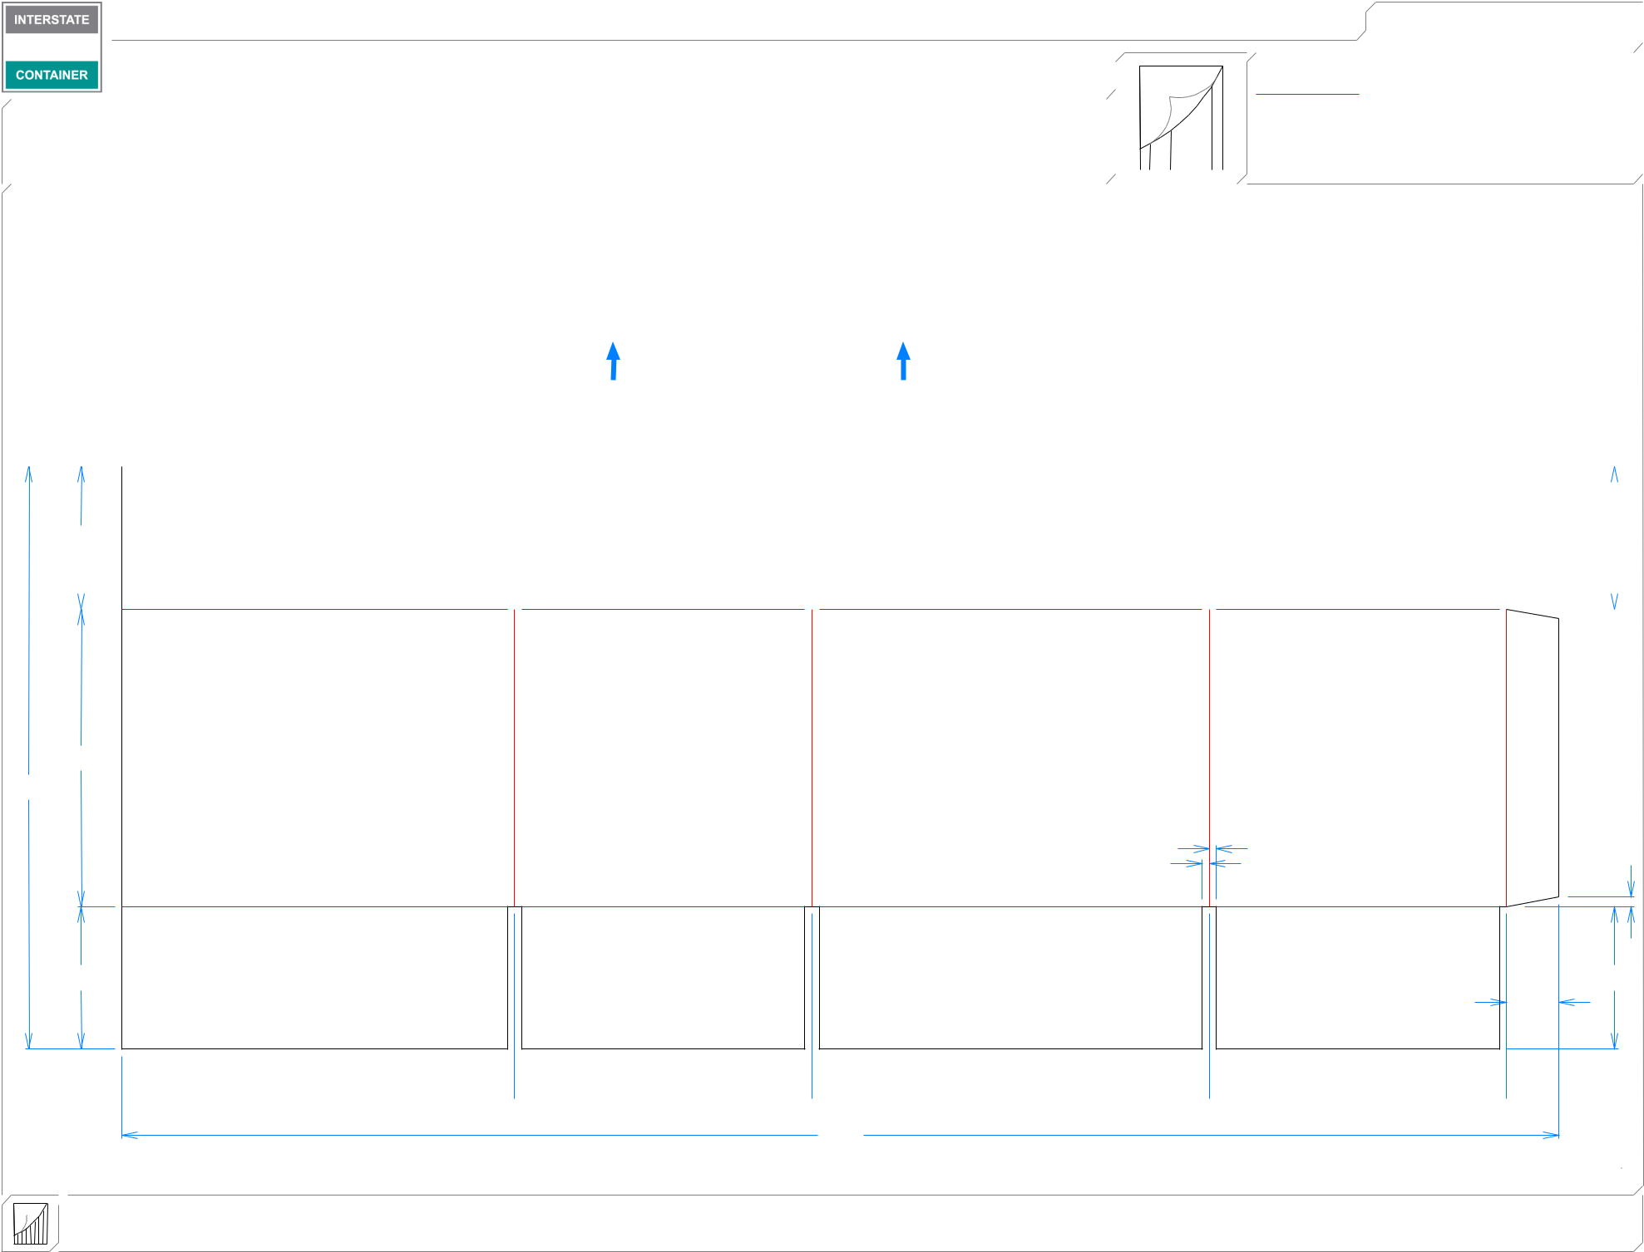

1. **OUT FFG**

**LEAD EDGE**

|  |  |  |  |  |  |  |  |  |  |  |  |  |  |  |  |  |
| --- | --- | --- | --- | --- | --- | --- | --- | --- | --- | --- | --- | --- | --- | --- | --- | --- |
| 33*/*4 | | |  |  |  |  |  |  |  |  |  |  |  |  |  |  |
|  |  |  |  |  |  |  |  | 33*/*4 | | | | |  |
|  |  |  |  |  |  |  |  |  |  |  |  |  |  |  |  |  |

3*/*16  3*/*16

|  |  |  |  |
| --- | --- | --- | --- |
| 713*/*16 |  |  |  |
| 155*/*16 |  |  |  |
| 3 | 3*/* | 1 |  |
| 16 | */*4 |  |
| */*16 | |  |  |
| 33*/*4 |  | 33*/*4 |  |
|  |  | 13*/*8 |  |

 105*/*16  713*/*16  107*/*16  713*/*16 

373*/*4

**inside view**

**Vertical Corrugation**

***notes:***

***Qty/unit:*** ***Area - waste:* 3.87 sq. ft** ***Waste on blank:* 3.5%** ***Piece weight - waste:* 0.52 lbs./236.28 g**